On the beat in  The Nedge  Safer Neighbourhood Team Newsletter | October 2023

In this edition…
- Scams…Be ALERT!!
- Neighbourhood watch
- Meet the team
- Trick or Treat
- Neighbourhood Matters

Scams…BE ALERT!!
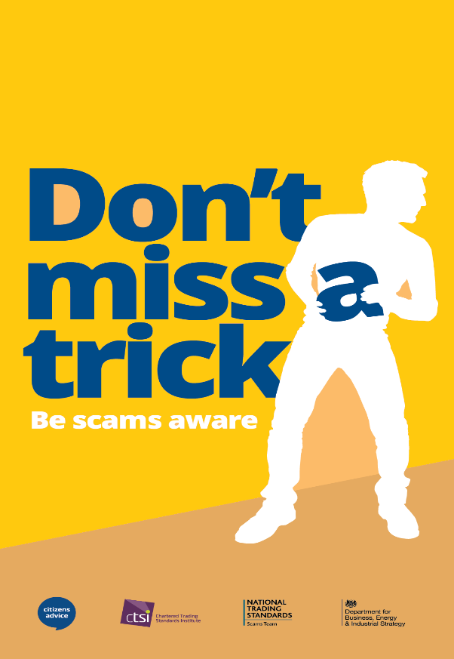
Ofgem have reported that scammers are sending emails and text messages appearing to be from energy suppliers or Ofgem itself offering rebates. This is a scam and the link could harvest your personal data so be scam aware.
Tips on how to avoid scams and what to do if you are affected –
- Stop
Reject, refuse or ignore contact claiming to be from Ofgem or an energy company that looks or sounds unusual, such as a request for your bank or personal details. They would never ask for this information.
- Check
Check email addresses. Any emails to or from Ofgem always end @ofgem.gov.uk. Look for other emails you have received from your energy provider and check it matches.
Check branding. The company logo will always be present in our communications. It should never look stretched, blurry or distorted.
Check your name. How do they usually address you? Is your name correct? If they usually address you by your first name – have they changed to Mr/Mrs – this could be an indication that something is wrong.

- Protect
Only criminals will try to rush or panic you.
End the call, forward the email to an address you trust at the company, call a number you know is right for the business and ask them if it was a genuine contact. Legitimate companies will be glad to help you avoid scammers and willing to review any material you have received.
Contact your bank immediately if you think you’ve fallen for a scam. Report it to Action Fraud if you live in England or Wales, and Police Scotland in Scotland. You can forward emails to – Report@phishing.gov.uk
You can find more help and advice here – https://www.takefive- stopfraud.org.uk/

Neighbourhood Watch
YOU are the eyes and ears of the community and Police often rely on information from residence in dealing with ASB, intelligence gathering and pro-actively dealing with issues effecting residents. If you would like to volunteer to set up a neighbourhood watch scheme where you live please contact your Safer Neighbourhood Team for further details. Alternatively pop along and meet the team at one of our neighbourhood surgeries advertised on Twitter @telfordcops, and discuss setting up a scheme.

Meet The Team
The engagement van has been out at various locations across the Nedge. Dates, times and locations will continue to be announced on our social media pages so come along and have chat, we look forward to seeing you all.
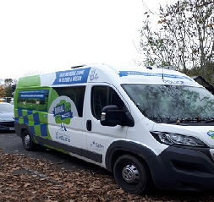
Trick or Treat

As Halloween approaches it is often a time for Spooky fancy dress, Scary decorations, and sweet treats galore if you are lucky enough, this makes the nights leading up to Halloween and the night itself, a fun occasion for all…(well almost all). Please be aware that some residents may not be comfortable having people calling at their homes during this time.
Below are 2 posters which can be printed off and displayed dependent on your preference. All trick or treaters are asked to respect the residents requests and above all stay safe, stay together and have fun.

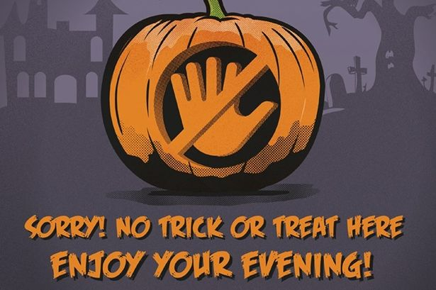



Neighbourhood Matters

Sign up to Neighbourhood Matters - Your brand new community messaging service.
 | Neighbourhood Matters enables residents, businesses and community groups to keep in touch with local policing teams. You can choose exactly what type of alert you wish to receive and how you receive them; whether that be by email, text or telephone.  Sign up now at: www.neighbourhoodmatters.co.uk alternatively scan the QR code below via your mobile device.
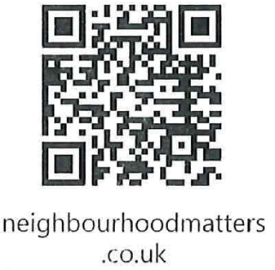
Contact Details
PC Johnston 21485
PCSO Roberts 40236
PCSO Ellis 40075



